
Company
Logotype

Cone Beam Computed Tomography- Report



Porur Dental X-rays & CBCT

Patient Name : Mrs. Vasanthi | Date of Report : 31.03.2024
Age/ Gender : 54 years/ Female | Region of Interest : CBCT Full Skull
Referring doctor: Dr. S, Sandhya | Indication : Implant assessment
Clinical Notes: Nil
PATIENT INFORMATION

CBCT- Full Skull provided
CBCT – IMAGE DETAILS

RADIOGRAPHIC INTERPRETATION

- Complete loss of crown and root structure in relation to 11, 13, 14, 15, 18, 22, 23, 24, 25, 27, 28, 35, 37, 38, 45, 46, 47.
- Root stumps in relation to 36, 43, 44, 48.
- The alveolar ridge in relation to the maxillary and mandibular alveolar ridge is present with normal trabecular pattern.

IMPLANT ASSESSMENT

 | 11 region | 12 region | 13 region | 14 region | 21 region | 22 region | 23 region | 24 region
Sub-Crestal | 5.8 | 7 | 4.2 | 4 | 7.3 | 5.2 | 3.8 | 5.6
Mid- Crestal | 6.7 | 6.8 | 4.8 | 4.6 | 8.6 | 5.8 | 5.8 | 7
Distance between the alveolar ridge and Floor of the Nasal cavity (in mm) | 20.9 | 18.1 | 19.8 | 18.9 | 20 | 19.1 | 18.8 | 18.6

 | 15 region | 16 region | 17 region | 25 region | 26 region | 27 region
Sub-Crestal (in mm) | 5.8 | 11.2 | 13.2 | 5.5 | 10.9 | 13.2
Mid- Crestal (in mm) | 7 | 11.7 | 13.5 | 6.8 | 11.9 | 14.2
Distance between the alveolar ridge and floor of the maxillary sinus (in mm) | 20.3 | 14.1 | 12.6 | 19.8 | 8.8 | 10.5

 | 31 region | 32 region | 33 region | 34 region
Sub-Crestal (in mm) | 5.9 | 7.8 | 7.9 | 6.6
Mid- Crestal (in mm) | 5.9 | 6.8 | 8.2 | 7.3
Distance between alveolar ridge and the inferior border of mandible (in mm) | 26.7 | 26.1 | 27 | 24.4

 | 41 region | 42 region | 43 region | 44 region
Sub-Crestal (in mm) | 5.7 | 7 | 8.1 | 7
Mid- Crestal (in mm) | 6.2 | 7 | 8.3 | 7.8
Distance between alveolar ridge and the inferior border of mandible (in mm) | 24.8 | 25.9 | 22.7 | 20.8
 | 45 region | 46 region | 47 region
Sub-Crestal (in mm) | 3.9 | 5.2 | 5.2
Mid- Crestal (in mm) | 5.8 | 8.2 | 8.7
Distance between alveolar ridge and the inferior alveolar nerve canal (in mm) | 13.3 | 12.9 | 11.9
Distance between alveolar ridge and the inferior border of mandible (in mm) | 24.2 | 23.8 | 23.3

 | 35 region | 36 region | 37 region
Sub-Crestal (in mm) | 4.8 | 6.2 | 4.3
Mid- Crestal (in mm) | 6.8 | 8.3 | 7.4
Distance between alveolar ridge and the inferior alveolar nerve canal (in mm) | 12.4 | 10.8 | 12.2
Distance between alveolar ridge and the inferior border of mandible (in mm) | 24.1 | 22.2 | 22.8

RADIOGRAPHIC IMPRESSION

- Partially edentulous maxillary and mandibular arch.
- Root stumps in relation to 36, 43, 44, 48.

Kindly correlate with clinical findings


IMAGES FOR REFERENCE

RECONSTRUCTED PANORAMIC VIEW

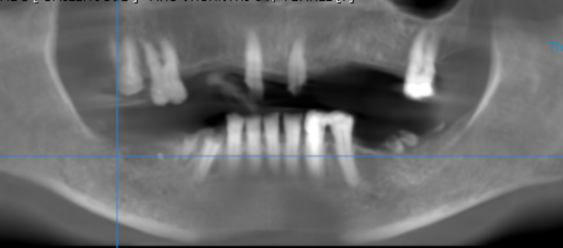

3-DIMENSIONAL VIEW

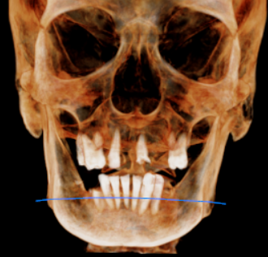

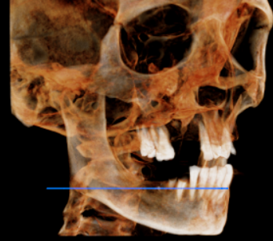
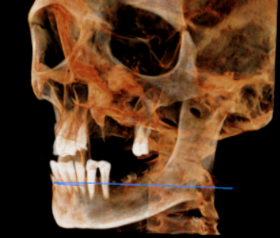

CROSS SECTIONAL VIEW

11 region | 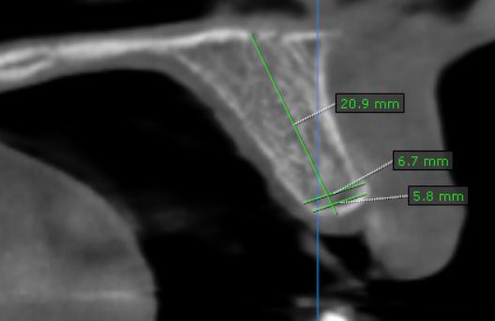
12 region | 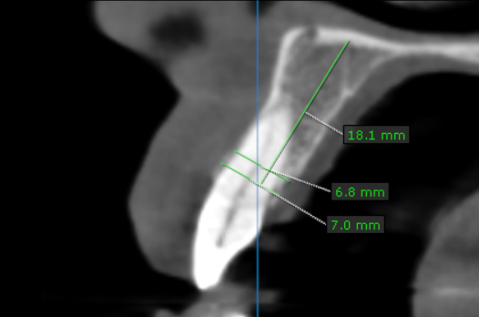
13 region | 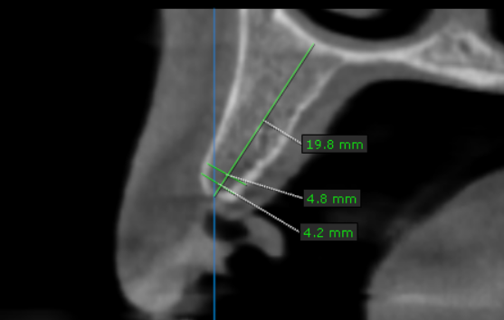
14 region | 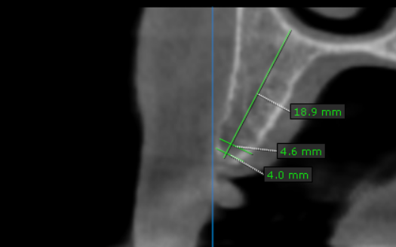
15 region | 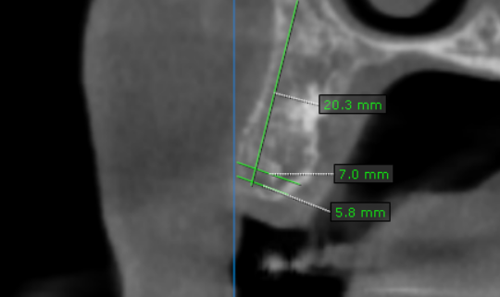
16 region | 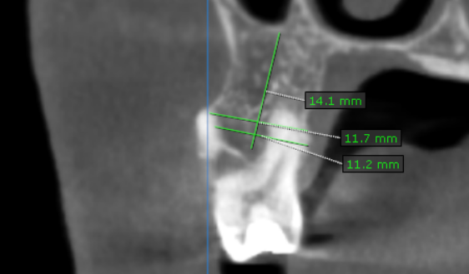
17 region | 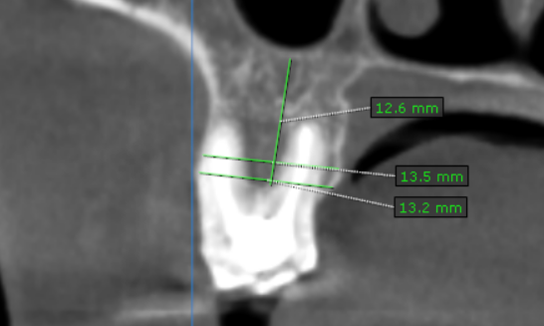
21 region | 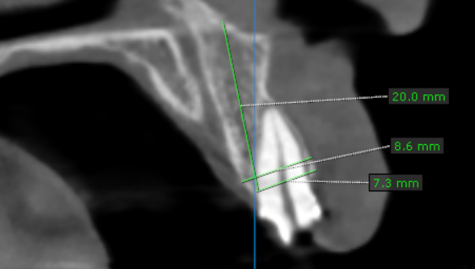
22 region | 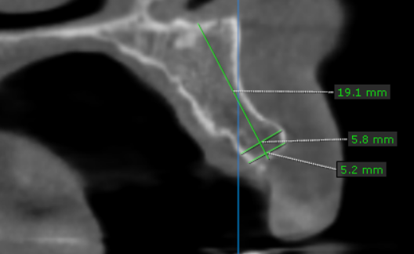
23 region | 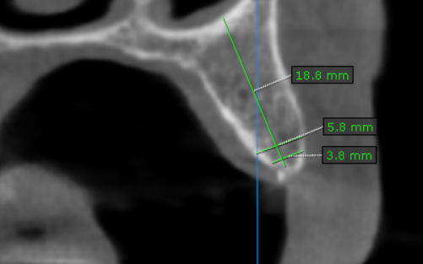
24 region | 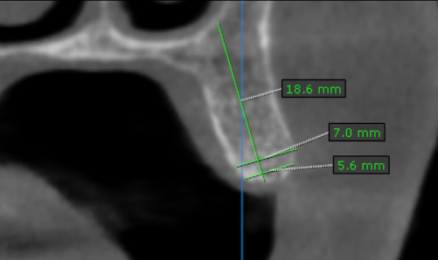
25 region | 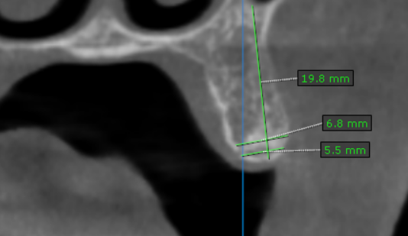
26 region | 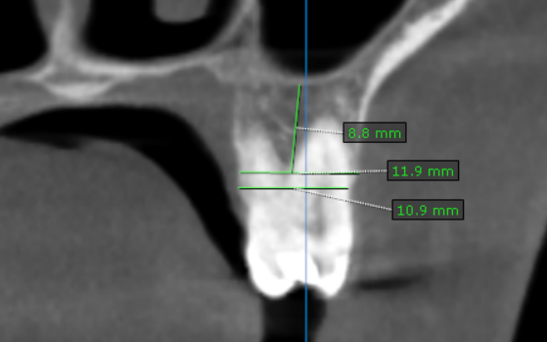
27 region | 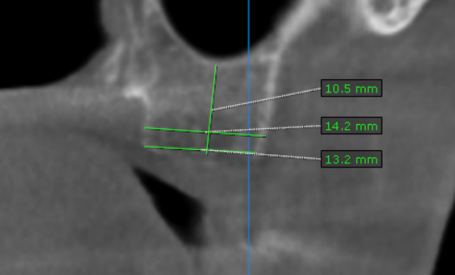
31 region | 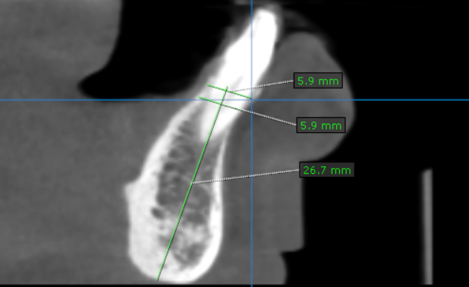
32 region | 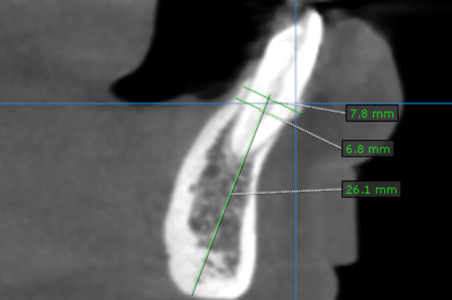
33 region | 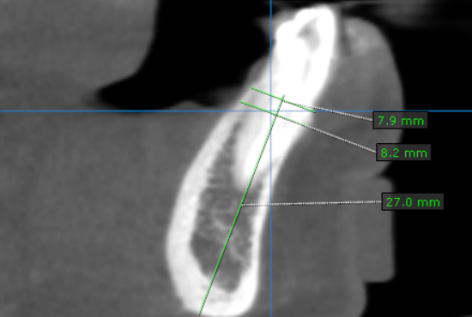
34 region | 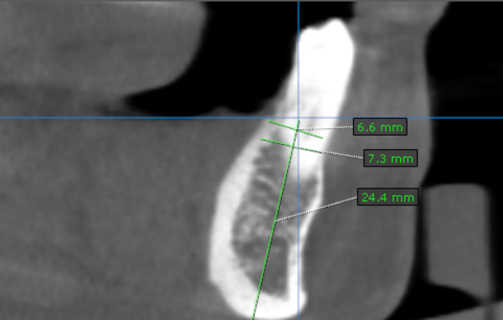
35 region | 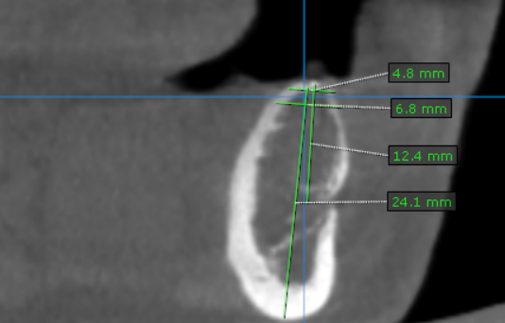
36 region | 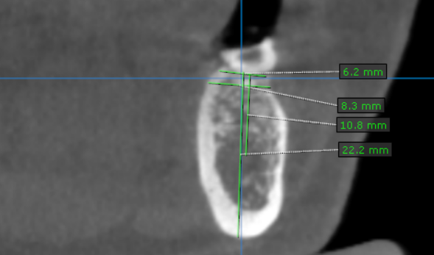
37 region | 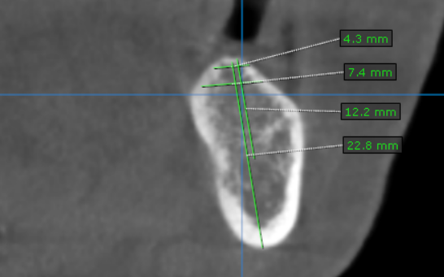
41 region | 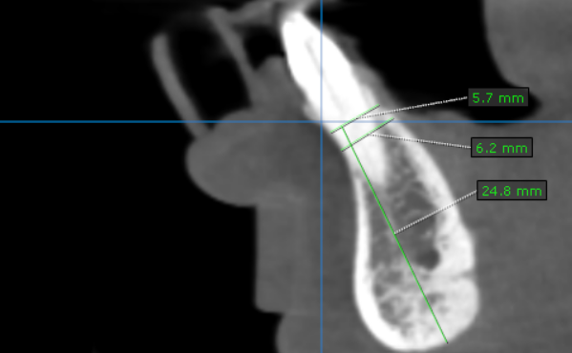
42 region | 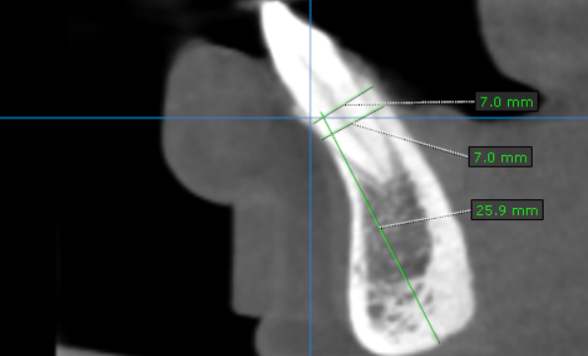
43 region | 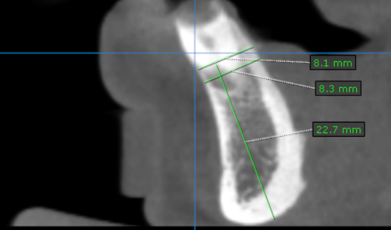
44 region | 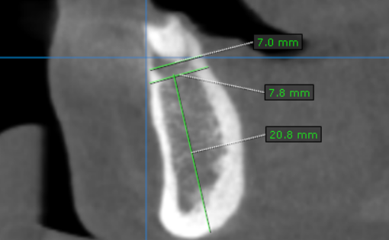
45 region | 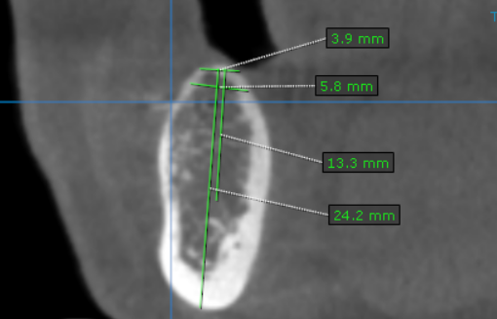
46 region | 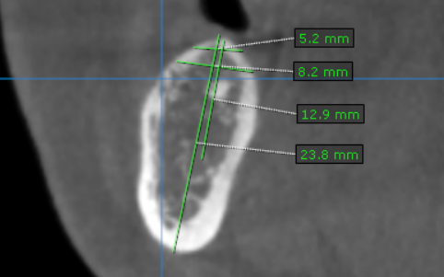
47 region | 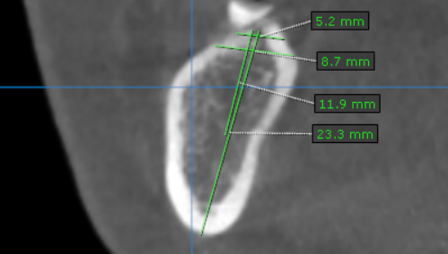

**** End of report ****

